1. **Creating a new mvc project and adding Extentions**

**-install SQLEXPRESS basic installation**

**-install SQL Server (mssql) extension in vscode**

**dotnet new mvc**

1. **Adding 4 package files.**

**dotnet add package Microsoft.EntityFrameworkCore**

**dotnet add package Microsoft.EntityFrameworkCore.Design**

**dotnet add package Microsoft.EntityFrameworkCore.Tools.Dotnet**

**dotnet add package Microsoft.EntityFrameworkCore.SqlServer**

1. **Add connection string in appsettings.json**

"Server=localhost\\SQLEXPRESS;Database=master;Trusted_Connection=True;MultipleActiveResultSets=True"

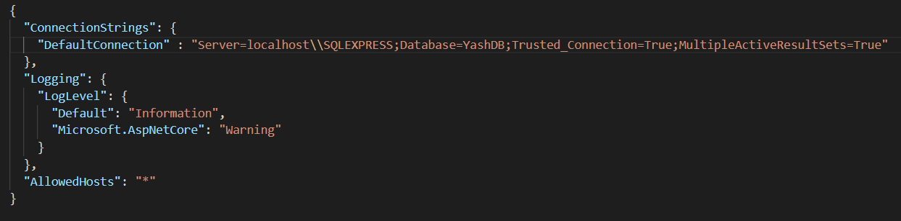

1. **Create a Student.cs Model FIle in Models folder**

using System.ComponentModel.DataAnnotations;

namespace MVC_Project.Models {

public class Student {

[Key]

public int Student_ID {get; set;}

[Required]

public string? Student_Name {get; set;}

[Required]

public int Student_Age {get; set;}

[Required(ErrorMessage = "Mobile Number is required!")]

[RegularExpression(@"^([0-9]{10})$", ErrorMessage ="Invalid Mobile Number.")]

public long Contact_No {get; set;}

}

}

1. **Create a Data Folder in the project folder and Create ApplicationDbContext.cs file**

using Microsoft.EntityFrameworkCore;

using MVC_Project.Models;

namespace MVC_Project.Data {

public class ApplicationDbContext : DbContext {

public ApplicationDbContext(DbContextOptions<ApplicationDbContext> options) : base(options) {

}

public DbSet<Student>? Student {get; set;}

}

}

1. **Dependency Injection in Program.cs file**

**-Move all statements in Program.cs in**

**Public class Program {**

**Public static void Main(String[] args) {**

**//Paste all statements**

**}**

**}**

**⇒ Add Following dependency after AddControllerwithViews**

builder.Services.AddDbContext<MVC_Project.Data.ApplicationDbContext>(

options=> options.UseSqlServer(builder.Configuration.GetConnectionString("DefaultConnection"))

);

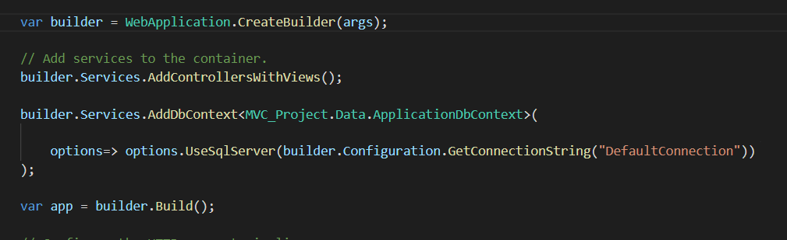

1. **Add a new link for student in Layout.cshtml in Projext/Views/Shared**

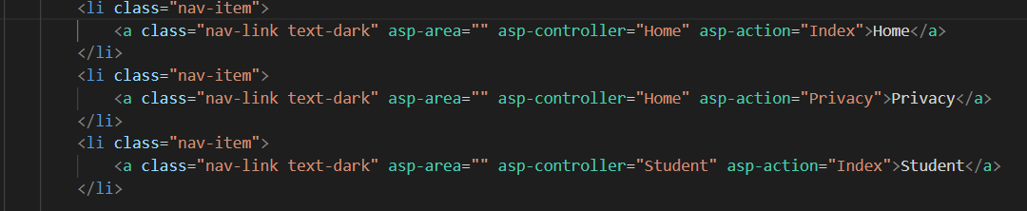

1. **Add Controller for Student in controller folder**

using Microsoft.EntityFrameworkCore;

using Microsoft.AspNetCore.Mvc;

using MVC_Project.Models;

using MVC_Project.Data;

namespace MVC_Project.Controllers {

public class StudentController : Controller {

private readonly ApplicationDbContext _db;

public StudentController(ApplicationDbContext _db) {

this._db = _db;

}

}

}

1. **Connect with mssql of Vscode to SQLEXPRESS**

**⇒ New Connection**

**⇒ localhost\SQLEXPRESS**

**⇒ Table name = master**

**⇒ Integrated**

**⇒ Connection name = anything**

1. **Add Dotnet ef tools, create initial migrations and update database**

**dotnet tool install - -global dotnet-ef**

**Dotnet ef migrations add InitialCreate**

**Dotnet ef database update**

1. **Refresh connection to check wether tables are created in master or not**
2. **Add student records in dbo.Student Table**

**⇒** 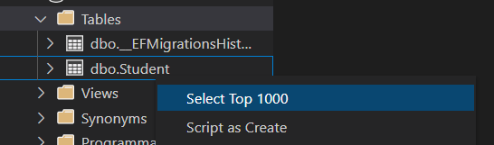

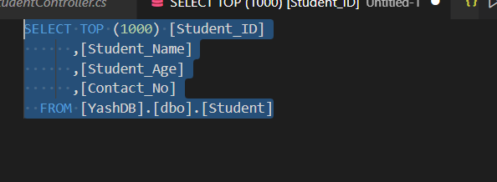

**Replace this code with**

**Insert into Student values(‘name’, age, contact)**

**.**

**.**

**.**

**.**

1. **Add View for Student’s Index page in Student folder**

**→ Create Student folder in View**

**→ Create Index.cshtml**

**→ Add Code for the view**